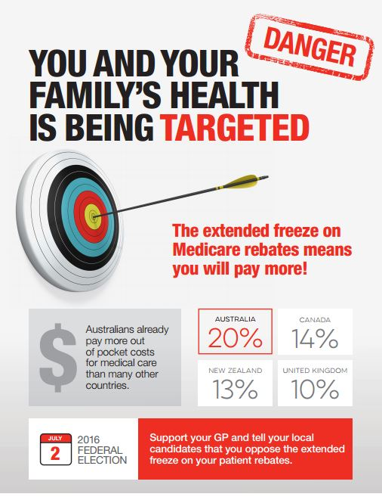

PROPER CARE NEEDS PROPER FUNDING
Ask your Federal Member of Parliament:
- Do they want all Australians to be able to access affordable and high quality General Practice care?
- If so, why do they keep cutting funding for General Practice, and why are they forcing GPs to increase their fees?
Sign the petition on www.change.org –
find it with a Google search for
“Sussan Ley Stop the Freeze”

Don’t let your access to healthcare be compromised by Government policy!

