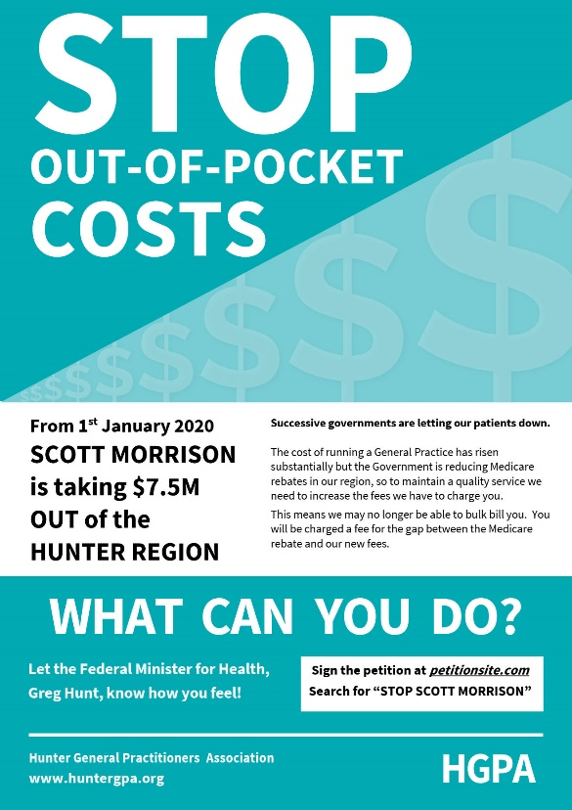

PROPER CARE NEEDS PROPER FUNDING
Ask the Federal Minister for Health:
- Does he want all Australians to be able to access affordable and high quality General Practice care?
- If so, why is he targeting General Practice in the Hunter by taking $7.5 MILLION out of our region, and $84,000 out of this practice?
- Why is he forcing GPs to increase their fees for the most disadvantaged and vulnerable – including our children?
Sign the petition - search for
“STOP SCOTT MORRISON”
at thepetitionsite.com

