Management of COVID-19 Patients in Nursing Homes – a GP Perspective – 03 April 2020
1. Preparation
- Update and Revise all advanced care plans with regard to wishes for treatment (nursing home care; hospital transfer; ICU; or palliation) in the event of mild Covid-19 or more severe Illness. Base this conversation on the realistic outcomes of this cohort of patients include the recent outback in Washington which resulted in multiple cases including 81 residents, 34 staff members, and 14 visitors and 27.1% of residents died, (McMichael et al, 2020).
- Document this decision with an ACP/MOLST and in GP notes.
- Ensure all nebulisers have been ceased. Spacers are more effective as well as less infection risk.
- Provide Influenza vaccine as soon as possible.
- Provide Pneumococcal vaccine if course not complete.
- Ensure facility has appropriate oxygen supplies and medications in stock, including antibiotics for secondary infections and palliative care medications. (insert link to see preparing for Oxygen Therapy in RACFs)
- Ensure adequate supplies of Personal Protective Equipment (PPE) by emailing agedcarecovidppe@health.gov.au to order PPE. Priority is given to facilities with COVID-19.
- Record daily baseline observations including O2 saturations for all residents for later comparison, if not already available. (Some patients with respiratory disease never reach 92% oxygen).
- Actively monitor all residents, staff and visitors at least daily for fever and respiratory symptoms. All staff should be screened for COVID if they have these symptoms and not return to work until they have negative swab results.
- Ask residents to report if they or other residents have respiratory symptoms.
2. Assessment of Residents with fever and/or respiratory symptoms
2.1 COVID19 should be considered in any resident or staff member with acute respiratory illness or fever (37.5 deg C or over). Residents (and their cohorts ie. room-mates, close contacts) require isolation and COVID-19 infection control procedures until result of swabs are known.

2.2 Swab Collection – refer to National Guidelines Coronavirus Disease 2019 (COVID-19) Outbreaks in Residential Care Facilities Appendix 4.
Residents require a single combined oropharyngeal and nasopharyngeal swab for SARS-COV-2 and Influenza, collected using standard and droplet precautions, recommended PPE, and recommended technique (oropharyngeal followed by nasopharyngeal with the same swab). NEJM Procedure: Collection of Nasopharyngeal Specimens
Sputum testing to be done if the lower tract is involved but requires special care and does not add much clinical information. It would be safest if sputum can be coughed up into a jar with the staff member at a distance
Request forms and labelled swabs and jar should be prepared beforehand and bags ready.
Double gloving and double bagging are recommended to keep outside of specimen bags “clean”, and immediate phone call to pathology made to arrange pick-up. Pathology laboratories will pick up tests but not do them.
On the pathology form, include the facility name and request that the results go to facility management and other doctors involved in care. Population Health Unit (PHU) should be informed direct by pathology, and can be contacted on
- Tamworth and Area Communicable Disease Team – ph 6764 8000
- Newcastle Communicable Disease Team – ph 4924 6477
- Taree Communicable Disease Team – ph 6515 1853
- 1300 066 055.
2.2 If Influenza is suspected oseltamivir (Tamiflu) can be offered within 48 hours and stopped if Influenza negative (Non PBS cost approximately $50) .
If Covid-19 is still strongly suspected on clinical grounds dry cough, fever, muscular pains but the swab comes back negative, consideration should be given for repeating the swab as the first result may be a false negative. If GPs are unsure about repeating swabs, contact ACE, PHU or infectious disease specialist for further advice.
2.3 Exacerbations of existing conditions. The usual differential diagnosis and management of cough and shortness of breath still apply. Influenza, infective exacerbation of asthma or COPD, bronchitis, bacterial and aspiration pneumonia and CCF may be present and need the usual management. However, COVID-19 may coexist with them and/or provoke exacerbations.
3. Infection control measures of SARS-COV-2 Positive Patients
All suspected cases and their close contacts, particularly those they share a room with, must be isolated in a single room with the door closed while awaiting results and all communal activities and meal sharing should cease. Healthcare workers need to wear surgical mask, eye protection, fluid resistant gown and gloves while providing care within <2 meters of a symptomatic resident, (CEC, 2020). The nursing home will need greatly heightened infection control for all residents during an outbreak.
When a positive result is received, notify the appropriate authorities and seek advice on where the resident can be best managed. Determine the risk versus benefit to the patient of hospital transfer. The patient needs early clinical assessment by a doctor. Understand the patient and their family’s wishes. If hospital care is thought to be required please call the GP, or if not available call the ACE service before transfer and please determine the patient’s goals of care particularly related to the hospital admission (see page 6). Other supports may be available in the RACF like palliative care and hospital in the home. My Emergency Doctor is a private company that is supporting NSW Ambulance for patient transfer. This service is run by Emergency Physicians interested in nursing home care. They can also assist you with clinical decision making as this is an ethically challenging decision for all clinicians.
3.1 Confirmed COVID-19 cases Suitable for Facility Care
- Patients with fever only or mild symptoms.
- Patients with moderate symptoms but haemodynamically stable where oxygen therapy can be provided. Morphine can assist with breathlessness
- Patients with an advanced care plan that requests “not for hospital transfer”.
3.2 Patients who may need admission to hospital
This would not include patients who are designated as “not for hospital” or those who have relevant treatment limitations identified in their ACP.
The below patients would benefit from more intensive supportive care than can be delivered in the RACF due to their symptoms being difficult to manage insitu.
- Significant and increasing respiratory distress.
- Increasing tachypnoea, especially RR > 30.
- Persistent and significant drop in usual O2 saturations (>10% from patient’s baseline)
- Signs of generalised sepsis (low BP, peripheral shutdown, decreased urine output, tachycardia, increased confusion and tachypnoea).
- CXR with new opacities (not explained by CCF), nodules or lobar collapse.
- High and rising CRP, falling platelets.
- Signs of cardiac complications (new cardiac pain, significantly raised troponin I, increasing and uncontrolled CCF)
Important things to consider for all patients being transferred to the ED are:
- Advance care planning wishes.
- Frailty and comorbid illness.
- Risks of transfer and potential benefits of hospital.
- RACF capability and capacity to attend to care needs. (This will be particularly important when an outbreak occurs and requires conversations with senior hospital and nursing home staff)
- Public health advice.

NSW Health has established a state-wide Secondary Triage System for ambulance calls for residents of nursing homes with potential COVID-19. This is an Emergency Physician consultation service. The emergency physician will contact the RACF for a telehealth consultation. If the patient is clinically suitable for hospital care, they will then be transferred to hospital for further assessment and care.
The GP is always the first point of contact for medical advice about the resident. If further advice is required, particularly regarding transfer, the GP or the nursing home nursing staff can call the ACE service (username: aged & password: care Ph: 1300 223 555.). The ACE call will also advise the hospital in advance that the resident is being transferred from a facility where there is potential or confirmed COVID-19 (CDNA, 2020)

3.3 Patients returning from any hospital visit
Any resident that visits hospital, even for a short ED visit, must be isolated for 14-days. This includes short visits to the ED. It is important that conversations with families and/or persons responsible understand this need for isolation. The nursing home will need to plan for the resident to return to a single room.
On return from any hospital visit a resident will need:
- A single room
- Regular observations at least twice daily
- Standard precautions.
If they develop respiratory symptoms or fever during their 14 days of isolation, they need swabs as well as droplet infection control precautions.
4. Further Investigation of COVID-19 Patients
Basic bloods will be done by pathology if designated urgent ie. FBC, UEC, LFTs, CRP
Troponin I and ECG if cardiomyopathy or cardiac ischaemia suspected.
CXR, if clinically indicated may be done as outpatient by some radiology companies eg.
Hunter Imaging has some isolation space and will consider on a case by case basis.
Compass Mobile Imaging will only perform X-Rays in facilities free of COVID-19. There is a list of X-Ray providers on the ACE website - COVID-19 Management. It is unlikely that private providers will perform X-rays on potentially COVID positive residents.

5. Planning for Treatment of COVID-19 in facility
5.1 Goals of treatment
- Review patient medications and eliminate possibly unhelpful medications if possible eg. NSAIDS, steroids, excessive diuretics, anti-cholesterol and anti-hypertensives. No consensus yet exists on ACE-I or ARBs.
- Nebulisers must not be used
- Antipyretic of choice is paracetamol. Ibuprofen should be used judiciously in this high risk group
- Adequate oral fluids. Subcutaneous normal saline could be used if patient is not drinking, clearly dehydrated and they are available at the ACF, but do not overload as this exacerbates lung congestion. Monitor fluid intake and urine output. Watch for fluid overload. (daily weights are helpful for this) Sub-cutaneous fluids at End of Life are not recommended. If a resident isn’t eating /drinking the outcome is very likely poor and palliation may be appropriate.
- Supplemental oxygen by nasal prongs to target 92% O2 saturation (88 to 92% for people with COPD) or as close to patient’s baseline as possible. Maximum flow of 4l/min via nasal prongs. (aerosolisation risk) Monitor respiratory rate and Oxygen saturations in case respiratory drive is decreased in CO2 retainers. (link to be inserted to preparing for oxygen therapy in RACFs)
- Treatment with empiric antimicrobials to cover all likely pathogens if secondary bacterial LRTI or sepsis suspected. (eTG Community-acquired pneumonia in aged-care facilities)
- Appropriate microbiology (MSU, wound swabs) in patients suspected of sepsis.
- Only use corticosteroids for exacerbation of asthma or COPD or septic shock
- Use inhalers/spacers. Do not use nebulisers.(link to be inserted)
- There are at this point no proven antiviral drugs. The use of Kaletra (link to be inserted) and hydroxychloroquine (link to be inserted) is not recommended outside of clinical trials. They have significant side effects.
5.2 Complications and concomitants to watch for and manage include:
- Dehydration, acute renal failure – strict fluid balance required. Balance fluids against overload, review diuretics, avoid nephrotoxins
- Delirium – control fever with Panadol; behavioural management strategies; psychotropics/anxiolytics/sedatives at lowest dose if necessary to relieve suffering, and prevent patient being a danger to self and others, including possible breaking of quarantine.
- Hypoxia – RACFs are developing plans for urgent access to oxygen
- CCF, Ischaemia, fast AF – treat as usual
- Sepsis – above
- Problems due to individual pre-morbidities – for example changes in BGLs in diabetic patients.
- Failure to respond to treatment – provide quality palliative care when needed. Please ensure residents have proactive PRN medications prescribed so they can be available.
  - Morphine may relieve pain and dyspnoea, midazolam agitation, myoclonus, and seizures
  - Maxalon for nausea and vomiting
  - Robinul (glycopyrronium) can relieve congested breathing due to secretions.
  - Further advice may be available from palliative care specialists. Calvary Mater Palliative Care Service on (02) 4921‑1211, and ask to speak with the rostered palliative care specialist, 24 hours a day, 7 days a week.
  - See also HNE P&EoLCare stream position statement and ELDAC prescriber guide on
  - Last Days of Life Anticipatory Prescribing Recommendations for In-Patient Setting – ADULT.
- 6. Release from isolation
Consult the CDNA National Guidelines for Public Health Units Coronavirus Disease 2019 (COVID-19) for the most current recommendations or contact PHU
References
Clinical Excellence Commission (2017). Last Days of Life Anticipatory Prescribing Recommendations for In-Patient Setting – ADULT. Last Days of Life Anticipatory Prescribing Recommendations for In-Patient Setting – ADULT. VERSION 2: APRIL 2017. Accessed 02/04/2020.
Communicable Diseases Network Australia (CDNA), 13/03/20. Coronavirus Disease 2019 (COVID-19) Outbreaks in Residential Care Facilities CDNA National Guidelines for the Prevention, Control and Public Health Management of COVID-19 Outbreaks in Residential Care Facilities in Australia. V1.
Clinical Excellence Commission (12 March 2020). Infection Prevention and Control COVID-19 (SARS-CoV-2) – Residential & Aged Care Facilities - Version 1.
McMichael TM, Clark S, Pogosjans S, et al. COVID-19 in a Long-Term Care Facility — King County, Washington, February 27–March 9, 2020. MMWR Morb Mortal Wkly Rep 2020;69:339-342. DOI: http://dx.doi.org/10.15585/mmwr.mm6912e1
NEJM Procedure: Collection of Nasopharyngeal Specimens
The Department of Health, 26 March 2020. Coronavirus Disease 2019 (COVID-19) CDNA National Guidelines for Public Health Units (COVID-19 SoNG).
Therapeutic Guidelines Limited April 2019. eTG Community-acquired pneumonia in aged-care facilities

Key phone numbers
ACE line - 1300 223 555
ACE website - http://ace.healthpathways.org.au/ Username: aged Password: care
Public health
- Tamworth and Area Communicable Disease Team – ph 6764 8000
- Newcastle Communicable Disease Team – ph 4924 6477
- Taree Communicable Disease Team – ph 6515 1853
NSW Ambulance
- to arrange transfer to ED by phoning 131233 - Option 3
- or if an emergency phone 000
My Emergency Doctors website
Goals of care are reflective of the advanced care directive, MOLST, and/or resuscitation plans.
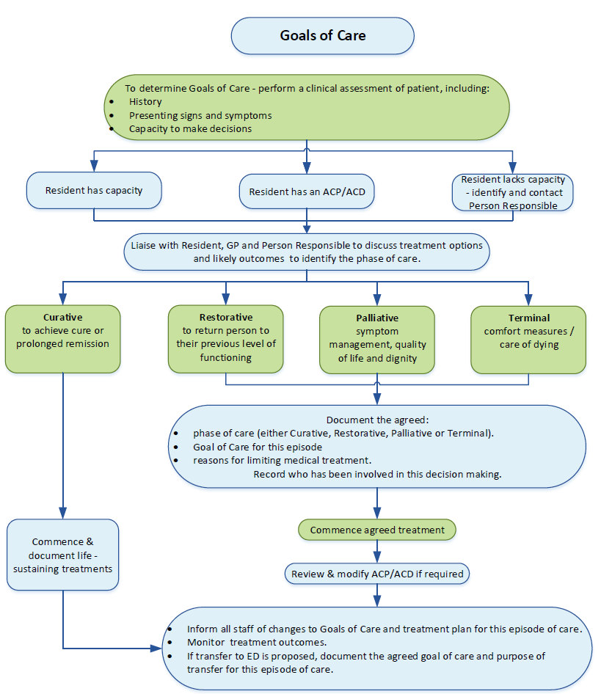
Flowchart adapted from Tasmanian Government, Department of Health and Human Services – implementing goals of care plan.

