Day 77 of planning

David Durheim, Population Health
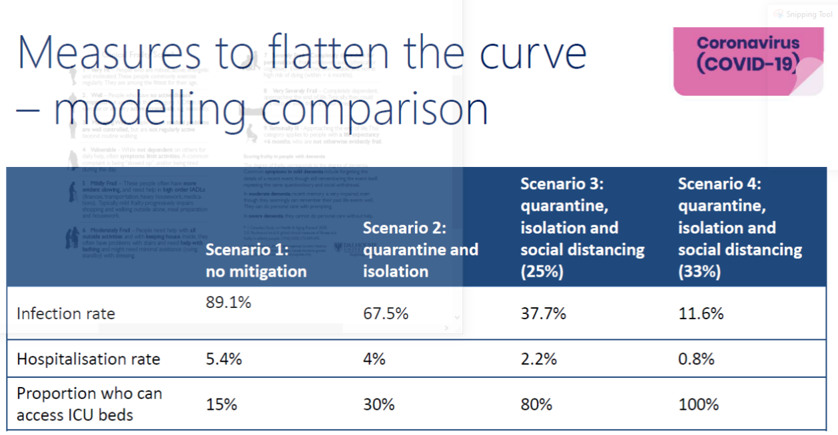

Australia, scenario 4
ICU capacity – current capacity, not surge capacity
Would prefer more testkits and higher testing rates
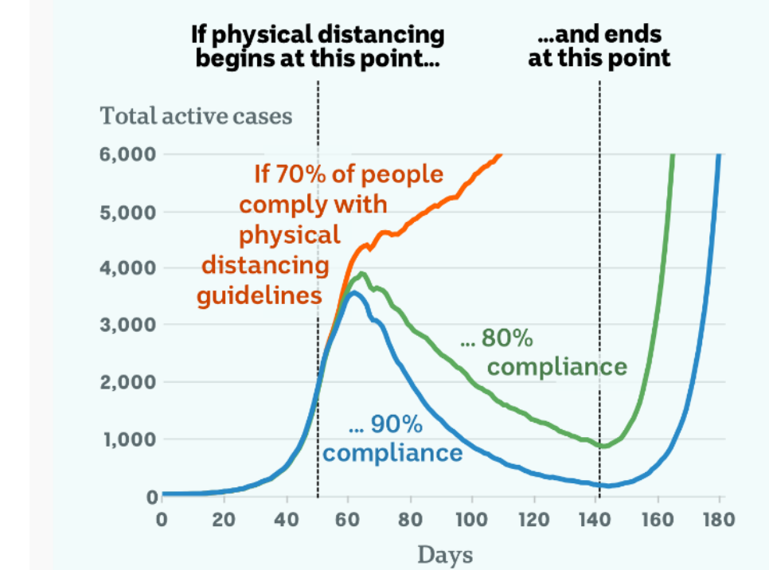

Australia 80-90% compliance
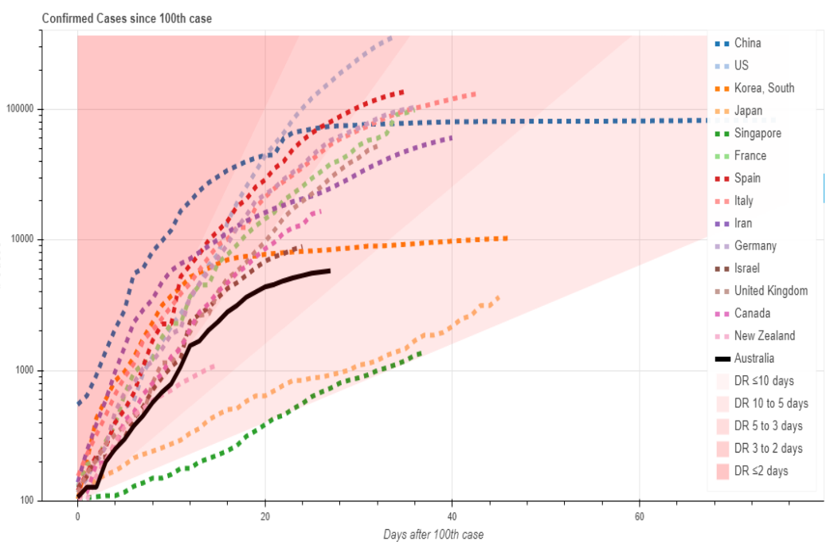
Aust flattening but still DR10-5 days
NZ – full lock down
Japan losing control as loosening control for Olympics, will increase isolation again
Australia should not reduce measures now
“Hammer and dance”, reduce distancing v gently, prob try in Tas first. With replication rate, reducing isolation could have huge negative impact

PAUL CRAVEN, MEDICAL CONTROL; LIZ GRIST, HSFAC

JOHN FERGUSON, INFECTIOUS DISEASES
Twitter MD@JKF – good stuff
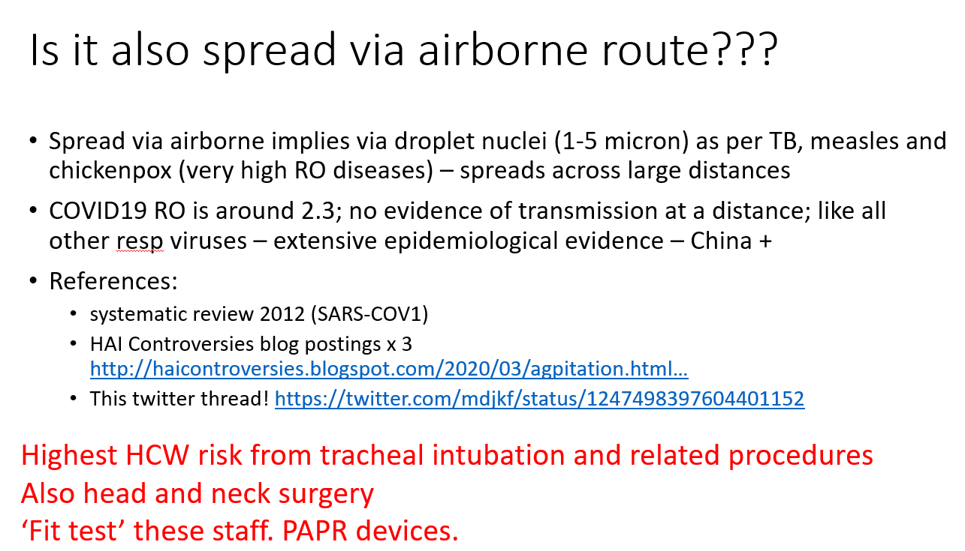

- Thinks routine use of eye protection (wrap around specs or visor) with mask and gloves for all patient contact
- Surgical masks can be worn 2-4 hours
- JHH getting vapour cleaning equipment for ICU equipment
- Hong Kong and others no health care worker acquisition of COVID when PPE sorted
- Midwives – changing masks, gloves and hand hygiene during labour

